1. Project Proposal Proposal for an AI model that can predict climate change using data (reports of temperature changes on Earth or in a specific region). This, with the goal of discovering indicators (factors, causes, relationships) to detect, treat, and prevent attributions related to long-term climate change. In the scope part: The model is focused on predicting climate change by showing the factors that influence these changes. The model does not have the scope to suggest or create climate change mitigation plans, it only shows results based on the data.

2. Detailed Solution Plan Indicate why the different AI techniques (Data science, ML, and GPR) will be used and why they will help in building the model with the expected results. Indicate where we intend to obtain the data to build and train the model.

As referenced in this report, https://www.nature.com/articles/s41612-020-00148-5, we can use a proven method machine learning model Gaussian Process Regression (<https://www.geeksforgeeks.org/gaussian-process-regression-gpr/>) to help us train and predict the ongoing climate changes.

#### **Import Libraries**

We need to import the libraries we’ll be using in the model creation.

* Pandas
* Numpy
* Matplotlib.pyplot - visualizations
* sklearn and its machine learning libraries

#### **Load dataset**

For the datasets, there is a free sourcing database at the national center for environmental information website- <https://www.ncei.noaa.gov/cdo-web/datasets> - where data sets in excess of gigabytes can be taken in csv formats over periods of time in regions, countries, states etc.

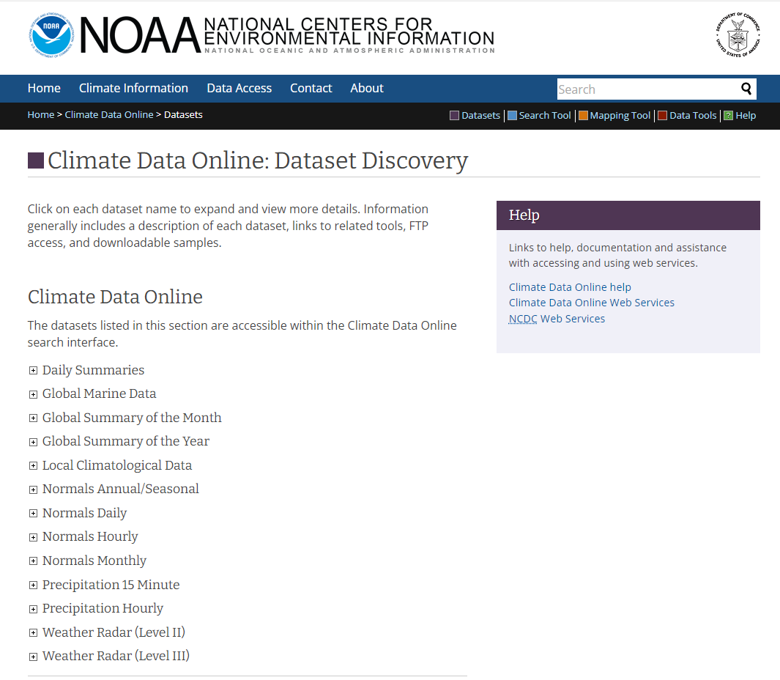

Once we have the dedicated region and dataset, we can download to a csv file and use pandas to read the data into a data frame using :

df = pd.read_csv(“”).

#### **Exploratory Data Analysis**

With the datasets loaded we can then perform EDA, or exploratory data analysis, on the weather data. This includes checking and getting rid of missing numbers, checking basic visualizations with different plots, and getting the features and number of entries.

**Data Processing**

We can pad any missing values that we deem necessary and select to keep or get rid of features most needed in our goal for climate prediction.

After processing the data, we build the model with x and y variables (X_train, X_test, Y_train, Y_test) for testing and training in a .2(test) to .8(train) ratio.

**Define and Train the GPR Model**

Using the variables with input data (X_train, X_test, Y_train, Y_test), we can fit those into the GPR (Gaussian Processing Regression) model to train and test.

#### **Make predictions and evaluate model**

In [ ]:

With a complete trained and tested model on historical data of any region and timeline that deem noteworthy, we can now start predictions to figure out the trend of climate change. Charting visualizations of past data and comparing future predictions visualizations, we can get a clearer picture of what direction we are headed towards, whether it be generally colder, warmer, or stay sporadic.

3. Test Plan The model is intended to obtain accurate predictions about climate change based on the indicators in the dataset. For example, the template shared by Adam shows the results with the test model. Explain what was done in the test model and what results were obtained